## Problem 1 – Mirrors

Create a Web page (HTML5 + CSS3 + images) that looks and behaves like the screenshots below:

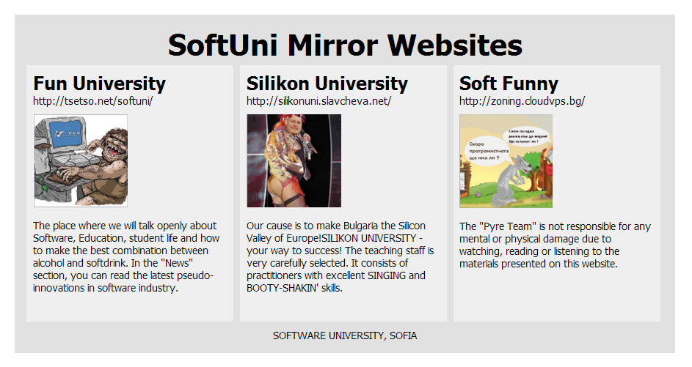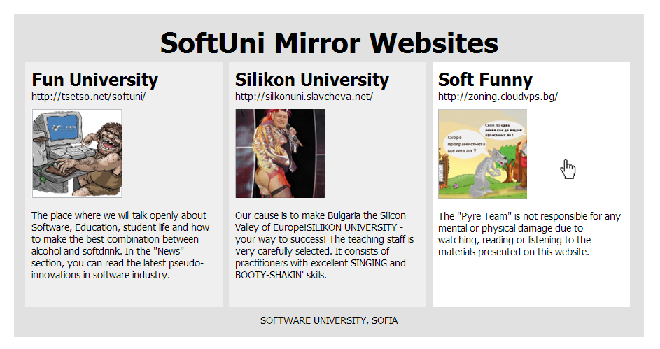

* The mouse hand-pointer in the screenshots is not part of your page, so please skip it.

### Input

You are given the above screenshots + the images for the above three news items + the texts on the site.

### Output

The output should be valid HTML5 + CSS3 + images that implement the above Web page.

### Constraints

* Font: Tahoma / Geneva / sans-serif.
* Fixed width: 870px.
* The site should open correctly in Chrome 35.
* Responsive design is not required.
* Pixel-perfect implementation is not required.